EARTHQUAKE-RESISTANT BUILDING DESIGN CONCEPTS
Mini Project Report | Civil Engineering

- Abstract

Earthquakes is one of the most devastating natural hazards, capable of causing catastrophic structural failures and significant loss of life. This report examines the fundamental principles and modern strategies employed in earthquake-resistant building design. It covers seismic force analysis, structural systems such as base isolation, shear walls, and moment-resisting frames, material selection, and code-compliance considerations under IS 1893 and international standards. Worked load estimations and comparative system analysis are included to provide a practical engineering perspective.

- Introduction

Seismic activity poses a critical threat to built infrastructure worldwide. Countries located on tectonic plate boundaries — including India, Japan, Turkey, and the western Americas — experience frequent and sometimes severe ground shaking events. The 2001 Bhuj earthquake (M 7.7) in India, for example, collapsed over 400,000 structures and claimed nearly 20,000 lives, highlighting the urgent need for seismically resilient construction practices.

Earthquake-resistant design does not aim to make a building earthquake-proof — a practical impossibility for extreme events — but rather to ensure: (a) no collapse under the design earthquake, (b) minimal damage under moderate shaking, and (c) full functionality under minor tremors. This performance-based philosophy underpins modern seismic design codes including IS 1893:2016 (India), ASCE 7-22 (USA), and Eurocode 8 (EU).

- Seismic Zonation & Design Parameters

India is divided into four seismic zones (II–V) based on expected ground motion intensity. Each zone carries a Zone Factor (Z) that directly scales the design seismic force on a structure.

Zone | Severity | Zone Factor Z | Example Regions
II | Low | 0.10 | South Tamil Nadu, Odisha coast
III | Moderate | 0.16 | Mumbai, Kolkata, Bhopal
IV | High | 0.24 | Delhi, Jammu, Sikkim
V | Very High | 0.36 | Himalayan belt, Andaman & Nicobar
 |  | Table 1: IS 1893:2016 Seismic Zone Classification

The design base shear V_{b} is calculated as:

V_{b} = A_{h} × W where A_{h} = (Z / 2) × (S_{a}/g) × (I / R)

Z = Zone factor, I = Importance factor (1.0–1.5), R = Response Reduction factor (3–5), S_{a}/g = Spectral acceleration, W = Seismic weight of building

PREPARED BY MANIK DEOGAM

EARTHQUAKE-RESISTANT BUILDING DESIGN CONCEPTS Mini Project Report | Civil Engineering

- Earthquake-Resistant Structural Systems

Multiple structural systems exist to resist seismic forces. The choice depends on building height, occupancy, available budget, and seismic zone. The three most widely adopted systems are detailed below.

4.1 Base Isolation Systems

Base isolation decouples the superstructure from the ground by inserting flexible bearings — typically laminated rubber or lead-rubber bearings — between the foundation and the building. During an earthquake, the isolators deform laterally while the building above remains nearly stationary, dramatically reducing acceleration transmitted to the structure (typically by 60–70%).


Floor 5

Floor 4

Floor 3

Floor 2

Floor 1

Isolator Pads (Rubber + Steel)


Ground / Foundation

Lateral■motion

Figure 1: Base Isolation System — Isolator pads absorb lateral ground motion

4.2 Shear Wall Systems

Shear walls are vertical reinforced concrete (RC) or steel plate elements that provide high in-plane stiffness and strength. Positioned at the building core and perimeter, they act as vertical cantilevers, transferring lateral seismic forces to the foundation. Shear walls can resist forces up to 35 storeys effectively and are highly economical.



F
Shear Wall (SW)

Floor Slab

Figure 2: Shear Wall Layout — Core and perimeter walls resist lateral seismic force

PREPARED BY MANIK DEOGAM

EARTHQUAKE-RESISTANT BUILDING DESIGN CONCEPTS Mini Project Report | Civil Engineering

4.3 Moment-Resisting Frames (MRF)

In an MRF, beams and columns are connected with rigid (moment-resisting) joints, enabling the frame to resist lateral loads through bending. Steel MRFs offer high ductility and are commonly used in zones IV and V. Reinforced concrete MRFs are economical for medium-rise structures (up to 15 storeys). The system allows architectural flexibility since no shear walls are required.
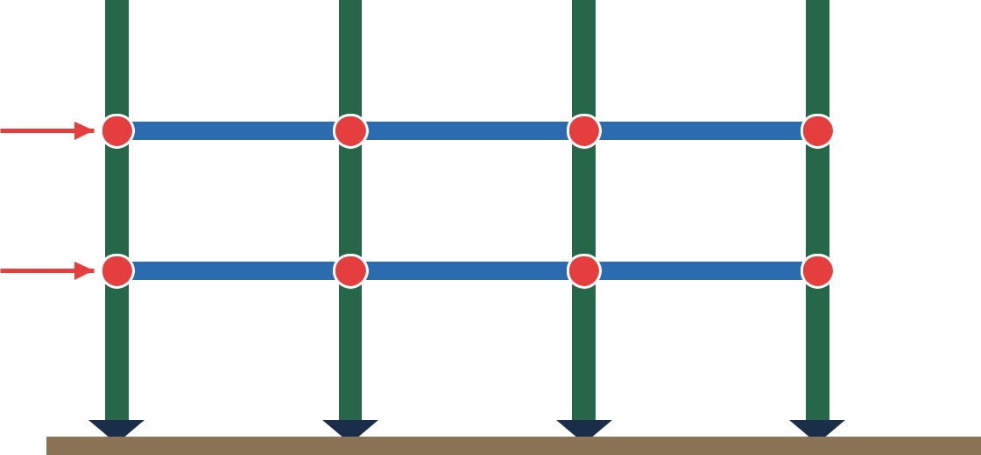

Moment-Resisting Frame

Rigid joint

Figure 3: Moment-Resisting Frame — Rigid beam-column joints redistribute seismic energy

- Load Path & Force Distribution

A well-defined load path ensures every force — gravity or seismic — travels continuously from its point of application to the foundation without interruption. Discontinuities (e.g., floating columns, soft storeys) create dangerous stress concentrations and are the leading cause of earthquake-induced collapse.


Roof Load


Floor Loads


Beam Transfer


Seismic &

Gravity

Loads
Column / Wall


Foundation

Figure 4: Vertical Load Path — Seismic and gravity loads travel from roof to foundation

PREPARED BY MANIK DEOGAM

EARTHQUAKE-RESISTANT BUILDING DESIGN CONCEPTS Mini Project Report | Civil Engineering

- Sample Load Estimation

Consider a 5-storey RC office building (30 m × 20 m plan) in Seismic Zone IV (Delhi). Using IS 1893:2016 with I = 1.0, R = 5 (SMRF), soil type II (medium), and T = 0.075 × h^{0.75} = 0.075 × 15^{0.75} ≈ 0.56 s:

Parameter | Symbol | Value | Unit
Building height | h | 15.0 | m
Floor area | A | 600 | m²
Dead load / floor | DL | 4.50 | kN/m²
Live load / floor | LL | 3.00 | kN/m²
Seismic weight W | W | ≈ 22,500 | kN
Zone factor | Z | 0.24 | —
Sa/g (T=0.56 s) | Sa/g | 1.79 | —
Design coeff. Ah | Ah | (0.24/2)×1.79/5=0.043 | —
Base Shear Vb | Vb | ≈ 967 | kN
Table 2: Sample Seismic Load Calculation (IS 1893:2016, Zone IV, SMRF)

PREPARED BY MANIK DEOGAM

EARTHQUAKE-RESISTANT BUILDING DESIGN CONCEPTS Mini Project Report | Civil Engineering

  - Key Design Principles

- Regularity in Plan & Elevation

Symmetric buildings with regular shapes perform significantly better in earthquakes. Irregular plans create torsional forces that multiply damage. IS 1893 defines regularity limits for both plan and vertical configurations.

2. Ductility & Energy Dissipation

Ductility is the ability of a structure to undergo large deformations without collapsing. Earthquake energy is dissipated through controlled yielding of specially detailed plastic hinges in beams (strong column – weak beam philosophy).

3. Avoiding Soft Storey Effect

A soft storey (open ground floor for parking) concentrates inter-storey drift and commonly leads to total collapse.

Remedies include infill RC frames, shear walls, or seismic isolation at ground level.

4. Diaphragm Action

Floor slabs must act as rigid diaphragms to distribute seismic forces to lateral load-resisting elements. Adequate reinforcement and continuity at slab edges is essential for effective diaphragm behaviour.

5. Redundancy

Multiple load paths ensure that failure of one member does not cause progressive collapse. Redundant systems with at least 3 bays of lateral resistance are preferred in high seismic zones.

6. Foundation Design

Isolated footings should be tied with grade beams to prevent differential settlement. Pile foundations are preferred in liquefiable or soft soils. IS 1904 provisions must be supplemented with seismic checks under IS 1893 Part 1.

- Material Selection for Seismic Resistance

Material |  | Key Property | Best Application | IS Grade
Fe 500D Rebar |  | High ductility | All RC elements | IS 1786
M30 Concrete |  | High strength | Shear walls, columns | IS 456
Structural Steel |  | Ductile, weldable | MRF, bracings | IS 2062
Fibre-RC (SFRC) |  | Crack control | Slabs, foundations | IS 516
Lead-Rubber Bearing |  | Energy absorb | Base isolators | IS 15935
 | Table 3: Recommended Materials for Earthquake-Resistant Construction

PREPARED BY MANIK DEOGAM

EARTHQUAKE-RESISTANT BUILDING DESIGN CONCEPTS Mini Project Report | Civil Engineering

- System Comparison & Selection Guide

Criterion | Base Isolation | Shear Walls | Moment Frame
Max. Height | Up to 10 storeys | Up to 35 storeys | Up to 15 storeys
Lateral Drift | Very Low (<0.2%) | Low (0.2–0.4%) | Moderate (0.5–2%)
Cost | High (bearings) | Moderate | Moderate–High
Ductility | Moderate | Moderate | Very High
Archi. Flex. | High | Constrained | High
Best Seismic Zone | IV & V (critical bldgs) | II–V | III–V
 | Table 4: Comparative Analysis of Seismic Structural Systems

- Conclusion

Earthquake-resistant building design is a multi-faceted engineering discipline that integrates structural mechanics, material science, geotechnical engineering, and regulatory compliance. The study demonstrates that:

- No single structural system is universally optimal — selection must be based on seismic zone, building height, occupancy, and budget.

- Base isolation is the most effective technology for protecting critical facilities (hospitals, emergency centres) in high seismic zones.

- Shear walls offer the best cost-to-performance ratio for typical residential and commercial buildings up to 35 storeys.

- Moment-resisting frames provide architectural flexibility and excellent ductility, making them suitable for mixed-use high-rise structures.

- Strict adherence to IS 1893:2016, IS 456:2000, and IS 13920:2016 detailing provisions is non-negotiable for safe seismic design.

- Regular plan geometry, continuous load paths, and ductile detailing remain the three pillars of any robust seismic design strategy.

- References

- Bureau of Indian Standards. IS 1893 (Part 1):2016 — Criteria for Earthquake Resistant Design of Structures. New Delhi: BIS.

- Bureau of Indian Standards. IS 13920:2016 — Ductile Design and Detailing of Reinforced Concrete Structures. New Delhi: BIS.

- Chopra, A.K. (2017). Dynamics of Structures: Theory and Applications to Earthquake Engineering (5th ed.). Pearson Education.

- Naeim, F. (Ed.). (2001). The Seismic Design Handbook (2nd ed.). Springer Science.

PREPARED BY MANIK DEOGAM

